CHEMICAL ENGINEERING TRANSACTIONS  VOL. , 2023 | A publication of
The Italian Association
of Chemical Engineering
Online at www.cetjournal.it

Guest Editors: Laura Piazza, Mauro Moresi, Francesco Donsì
Copyright © 2023, AIDIC Servizi S.r.l.
ISBN 979-12-81206-01-4; ISSN 2283-9216

Alternative protein and fiber-based cheese and hamburger analogues: meeting consumer demand for differentiated plant-based products
Selene Daiha Benevides^{a,}*, Nédio Jair Wurlitzerª, Ana Paula Dionisioª, Deborah dos Santos Garrutiª, Guilhermina Maria Vieira Cayres Nunes^{b}, Bárbara Alves Chagas^{c}, Juliana Maria Rabeilo Bessa^{c}, Paulo Henrique Machado de Sousa^{d}
ªEmbrapa Agroindústria Tropical, Dra Sara Mesquita Street, 2270, 60511-110, Fortaleza, CE, Brazil.
^{b}Embrapa Cocais, Praça da República, 147 - Diamante, 65020-500, São Luís, MA, Brazil.
^{c}Department of Food Technology, Federal University of Ceará, Av. Mister Hull, s/n, 60455-760, Fortaleza, CE, Brazil.
^{d}Institute of Culture and Art, Federal University of Ceará, Av. Mister Hull, s/n, 60455-760, Fortaleza, CE, Brazil.
*Corresponding author: selene.benevides@embrapa.br

The importance of functionality in food has led to the development of a potential market for ingredients such as dietary fiber and alternative proteins, expanding their insertion in beverages and cheese and meat analogues. Alternative proteins include various production processes aimed at the plant, fermentative, and cell culture products. There is a worldwide trend of innovative products made by combining technologies to reach this market niche. Embrapa has developed plant-based products, such as milk, cheese, and hamburger analogues, based on babassu coconut and cashew nuts, freeze-dried cashew fiber, and alternative proteins, such as chickpeas, lentils, and the microalgae Spirulina (Arthrospira platensis). The babassu coconut cheese analogue was processed by crushing the kernels to obtain the water-soluble extract, pasteurizing, fermenting by mixed cultures and heating the water-soluble extract fermented with soy, starch, agar, and salt to form the dough, followed by packaging and storage at 4°C. The hamburger analogues based on freeze-dried cashew fiber, lentils, or chickpeas, and freeze-dried Spirulina microalgae were added with other ingredients used in traditional hamburgers, followed by molding and freezing at -18 ºC. The hamburger analogue had a protein content of 14-18% on a dry basis, and the babassu coconut analogue was 4.17%, and both achieved a sensory acceptance of 7 on the 9-point hedonic scale. The products achieved purchase intention values of 3.7 and 4.0 respectively, showing market potential to meet the demand of consumers looking for functional and tasty foods.
  - Introduction
The cashew tree (Anacardiaceae family) presents mainly in North and Northeast of Brazil and part of other countries have a fruit that is a nut, but the peduncle (pseudo fruit or cashew apple), is fibrous and is a co-product of the juice extraction in a fruit industry (Figueiredo et al., 2002). Cashew bagasse, a by-product generated in these agroindustries has a high fiber content (12%) (Pinho et al., 2011), enabling its use as a meat substitute ingredient in the preparation of plant-based products, replacing animal products such as hamburgers and meatballs (Sucupira et. al., 2020), among others. Cashew fiber is a potentially valuable biomass that, when used as a new food matrix in plant-based product formulations, meets part of the dietary needs of groups of people who seek to consume fiber-rich products, but also those who want to reduce or avoid meat consumption, such as vegetarians and vegans, in addition to the general public who choose this line of products.
Fiber diets have been recommended as they have significant protective effects against chronic diseases such as type 2 diabetes, cardiovascular disease, and obesity (Müller et al., 2018). The use of cashew fiber in the production of animal protein-free foods has been a great asset in providing a surprising texture very close to that of animal meat, in addition to bringing nutritional benefits. Sucupira et al. (2020) observed that both artisanal and industrial cashew apple ﬁbers presented a rich composition in the bioactive compounds, especially regarding the content of ascorbic acid found in artisanal (147.8 mg.100g -1) and carotenoids in industrialized ﬁber (1.87 mg 100 g -1), which resulted in a higher antioxidant activity for both methods evaluated.
Several studies by the Brazilian Agricultural Research Corporation (Embrapa) have demonstrated the feasibility, through good sensory acceptance, of using cashew fiber as a matrix for the preparation of hamburger-type products, both as a single component (Galvão, 2006; Lima, 2008), as incorporated with alternative proteins. The addition is due to the low protein content of cashew fiber, making it necessary to increase this content, especially when considering products similar in composition to products of animal origin. Soy was the pioneering alternative protein (Lima et al., 2013a, 2016), followed by cowpea (Lima et al., 2013b), and cashew fiber with cowpea (Lima et al., 2018). Legumes such as lentils and chickpeas have been used to increase the protein content in products such as hamburgers, as they have approximately 20-40%/ and 20-52%, respectively.
The biomass of the microalgae Spirulina (Arthrospira platensis) has been a trend of alternative protein for meat analogues. Kumar et al. (2022) since it has about 50% of proteins, in addition to fibers, vitamins, minerals, and polyunsaturated fatty acids.
As a way of diversifying babassu products, Embrapa developed a cheese analogue based on babassu kernels with good sensory acceptance, and its technology was passed on to coconut breakers in Maranhão and Ceará states, with the prospect of future transfers to communities and producers interested. The babassu coconut kernel has about 1.42% of titratable acidity, 7.21 pH, 1.06% of ash, 9.03% of humidity, 12.23% of proteins, 50.10% of lipids, 27.58% carbohydrates, and 51.53% fibers (De Oliveira et al., 2019), being highly energetic, estimated at 420 kcal per 100 grams of sample. Babassu coconut milk has as predominant components moisture and fat with about 75.40% and 20.30%, respectively, with 2.45% of proteins, 0.27% of ash, 0.072% of total acidity, and 6.80 pH (Carneiro et. al., 2014). A survey on consumer perception and emotional responses towards vegetable cheeses indicated that they consider these products healthier than conventional cheeses, but do not appreciate the flavor or texture attributes very much, even if they are soft and have “buttery” and smooth attributes but find that they leave a residue in the mouth, have a rubbery appearance and strange flavors (Falkeisen et al. 2022).
Therefore, it is a challenge to develop cheese analogue technologies that meet the expectations of consumers who want products that are like traditional cheeses, mainly in sensory attributes such as flavor and texture.
The growing worldwide interest in foods of plant origin is directly linked to the objective of this work, to evaluate the acceptance of vegetable products such as hamburgers and cheese, based on cashew fiber with lentils and Spirulina, and babassu coconut kernels, respectively, meeting the demand of consumers who do not want or cannot consume protein of animal origin.
  - Materials and methods
2.1 Hamburger analogue
The wet fibers of the cashew peduncle were donated by local industries and transported to Embrapa Agroindústria Tropical, both in Fortaleza, in the State of Ceará, Brazil. The fibers are pressed in an expeller press, with successive washes, in order to reduce the acidity and the characteristic flavor of the fruit. Then, the still-wet fiber was frozen (-18 ± 1 ºC) and subsequently dehydrated in a pilot lyophilizer (Liobrás LP 510) with a 30 h cycle and a final product temperature of 30 ºC. The lyophilized fiber was taken to the rotating blade mill (Fritsch brand, Model Pulverisette 19) to reduce the particle size to less than 0.5mm. Then, the fiber packed in plastic bags was stored at room temperature until its use in the formulations.
The legume Lentil Silvina (LentSil) was provided by Embrapa Hortaliças, located in the Federal District, Brazil. The grains were hydrated in potable water for 24 h under refrigeration at 8 °C. Then, the drained grains were processed in a domestic multiprocessor (Mallory - Bravo) to reduce the granulometry to less than 0.5mm, and homogenized until obtaining a paste to be used in the formulations.
The biomass of the microalgae Spirulina (Arthrospira platensis) was provided by the Department of Fishery Engineering at the Federal University of Ceará (UFC). The summary of the process steps of the hamburger analogue with cashew fiber, pea and Spirulina (Figure 1).
Hamburger molding and freezing

Wet fibers pressed with successive washes

Reduction of granulometry of the dehydrated fiber

Lentil grains
in potable water (24 h)
under refrigeration
Hydrated lentil grains processed to obtain the paste
Biomass of hydrated Spirulina microalgae and other ingredients

PROCESS STEPS

Figure 1: The summary of the process steps of the hamburger analogue with cashew fiber, pea and Spirulina.
Other ingredients commonly used in traditional hamburger formulations were used, such as corn starch onion powder, soy oil, salt, granulated garlic, dehydrated parsley and black pepper.

2.2 Cheese analogue
The overall process of cheese analogue involves stages of selecting the babassu coconut kernel, sanitizing the kernels with boiling water, extracting the milk analogue, fermenting with a mix of culture of Chr. Hansen (Lactobacillus helveticus, Lactococcus lactis subsp. cremoris, Lactococcus lactis subsp. lactis and Streptococcus thermophilus), heating the water-soluble extract fermented with other ingredients, packaging and storage (Figure 2).

Packaging and storage the cheese analogues
Selection of babassu coconut kernels
Sanitization of babassu coconut kernels
Extraction of milk analogue kernel:water
(1:2)
Babassu coconut milk fermenting in BOD
Heating the fermented milk analogue with other ingredients
PROCESS STEPS

Figure 2: Summary of the stages of the cheese analogue process based on babassu coconut kernels.
2.3 Chemical, physical-chemical and instrumental analyzes of analogues products
Moisture, protein, lipids, and ash analyzes were performed on the hamburger and babassu cheese analogues.
Texture profiling (TPA), total acidity and pH were realized in cheese analogue.
The moisture and ash content was obtained according to AOAC (2016), method 925.10 e 923.03, respectively. The lipid content was determined by method nº Am 5-04 of the American Oil Chemists’ Society (AOCS, 2005), using the extraction system under high pressure and high temperature in Ankom XT-15 equipment (ANKON Technology Corporation, 2009).
Protein determination was performed by combustion, according to the DUMAS method, in Nitrogen/Protein Analyzer NDA 701 Dumas equipment (VELP, 2019), using EDTA as standard, based on the AOAC 992.23 method (AOAC, 2016).
The carbohydrate content was determined by difference with the values found for moisture, proteins, lipids, and ash.
Texture profiling (TPA) of the cheese analogue was performed on a TA-TX2i texturometer (Stable Micro Systems Ltd., Surrey, England), equipped with a 30 kg load cell. The samples were molded into cylinders of 1.9 cm in diameter and 2 cm in height, and the test speed was 1 mm/s, with a 5 g trigger. Eight cylinders were subjected to two consecutive cycles with 50% compression, using a P35 probe, and the parameters of adhesiveness, hardness, gumminess and chewability were calculated.
Total acidity and pH were measured in the cheese analogue according to the method AOAC titration (2016) and digital pH meter reading (Mettler Toleto, model F20, Ohio, USA), respectively.

2.4 Sensorial analysis of analogous products
Global acceptance and purchase intention were evaluated by 50 untrained tasters for both products, at different times, according to a 9-point hedonic scale ranging from 1 (I disliked it very much) to 9 (I liked it very much) according Meilgaard (1987). The scale used to assess purchase intention consists of 5 points, ranging from 1 (definitely would not buy) to 5 (definitely would buy). The procedures adopted in this research were approved by the Research Ethics Committee (CEP), in accordance with national (Resolution nº 466/12 and Resolution nº 510/16 of the National Health Council) and international (CIOMS) guidelines.

2.5 Data evaluation
The data obtained from the chemical, physical-chemical and instrumental analyzes were submitted to analysis of variance and Tukey's test with a significance level of 5% to compare the mean and standard deviation (SD) using the statistical program XLSTAT 2021.
  - Results and discussion
The cashew fiber hamburger analogues with legumes and Spriulina and babassu cheese (Figure 3) showed, as shown in Table 1, the average of the results obtained in the analyses.

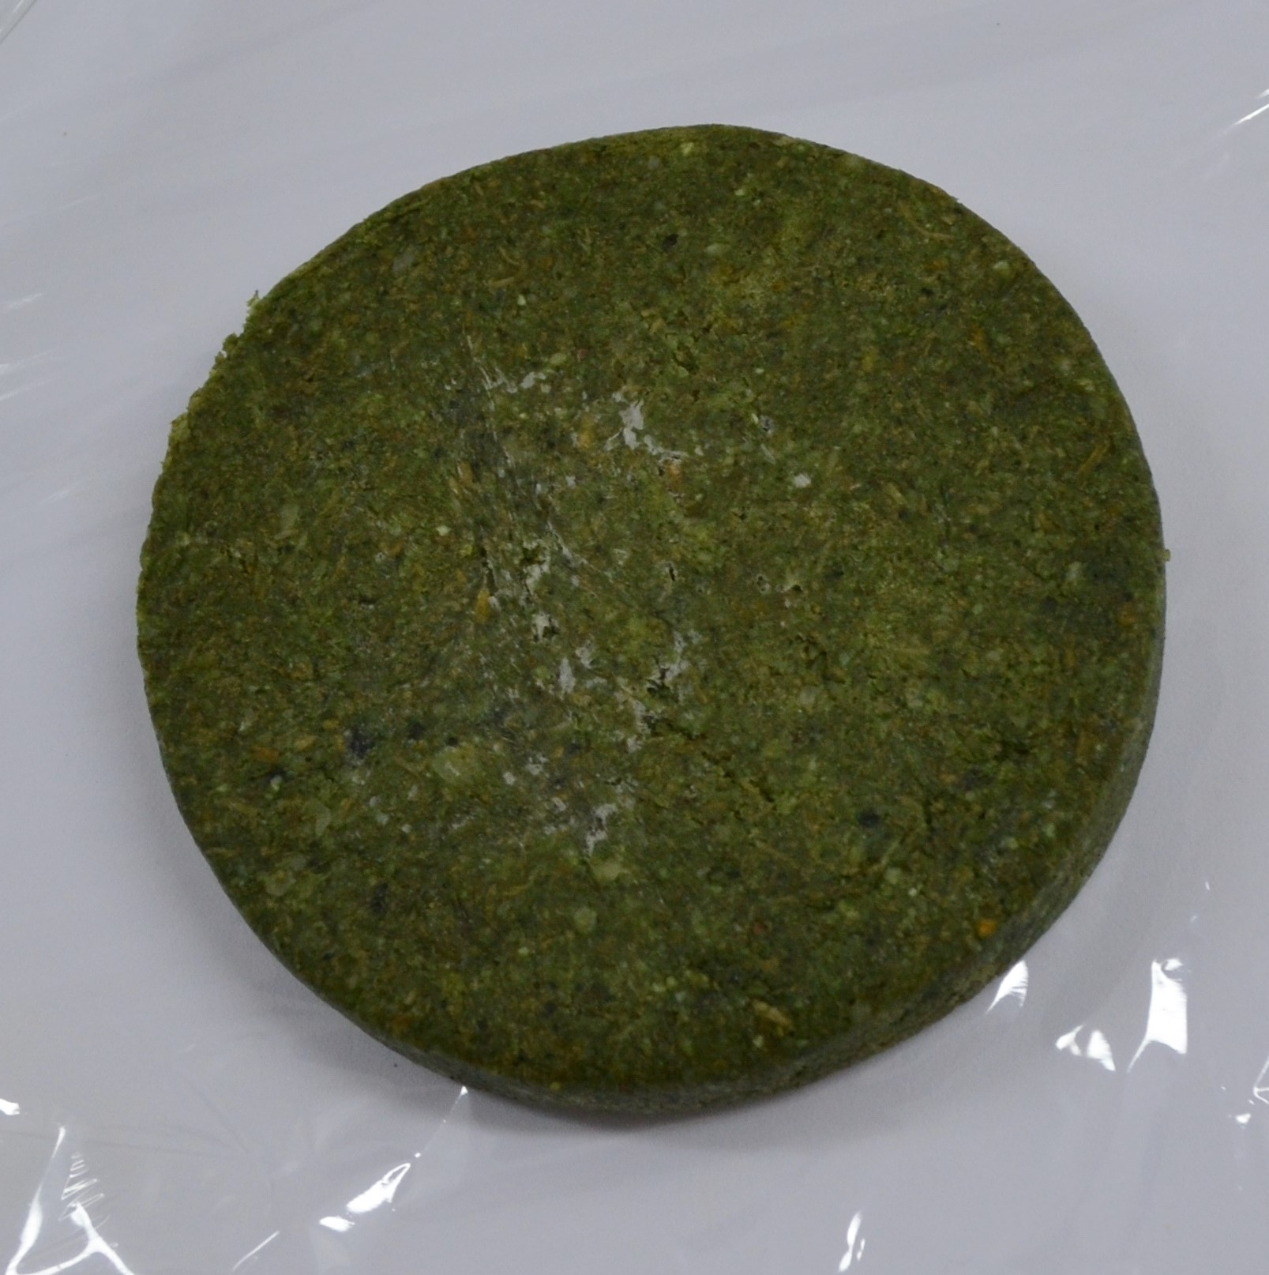  a | 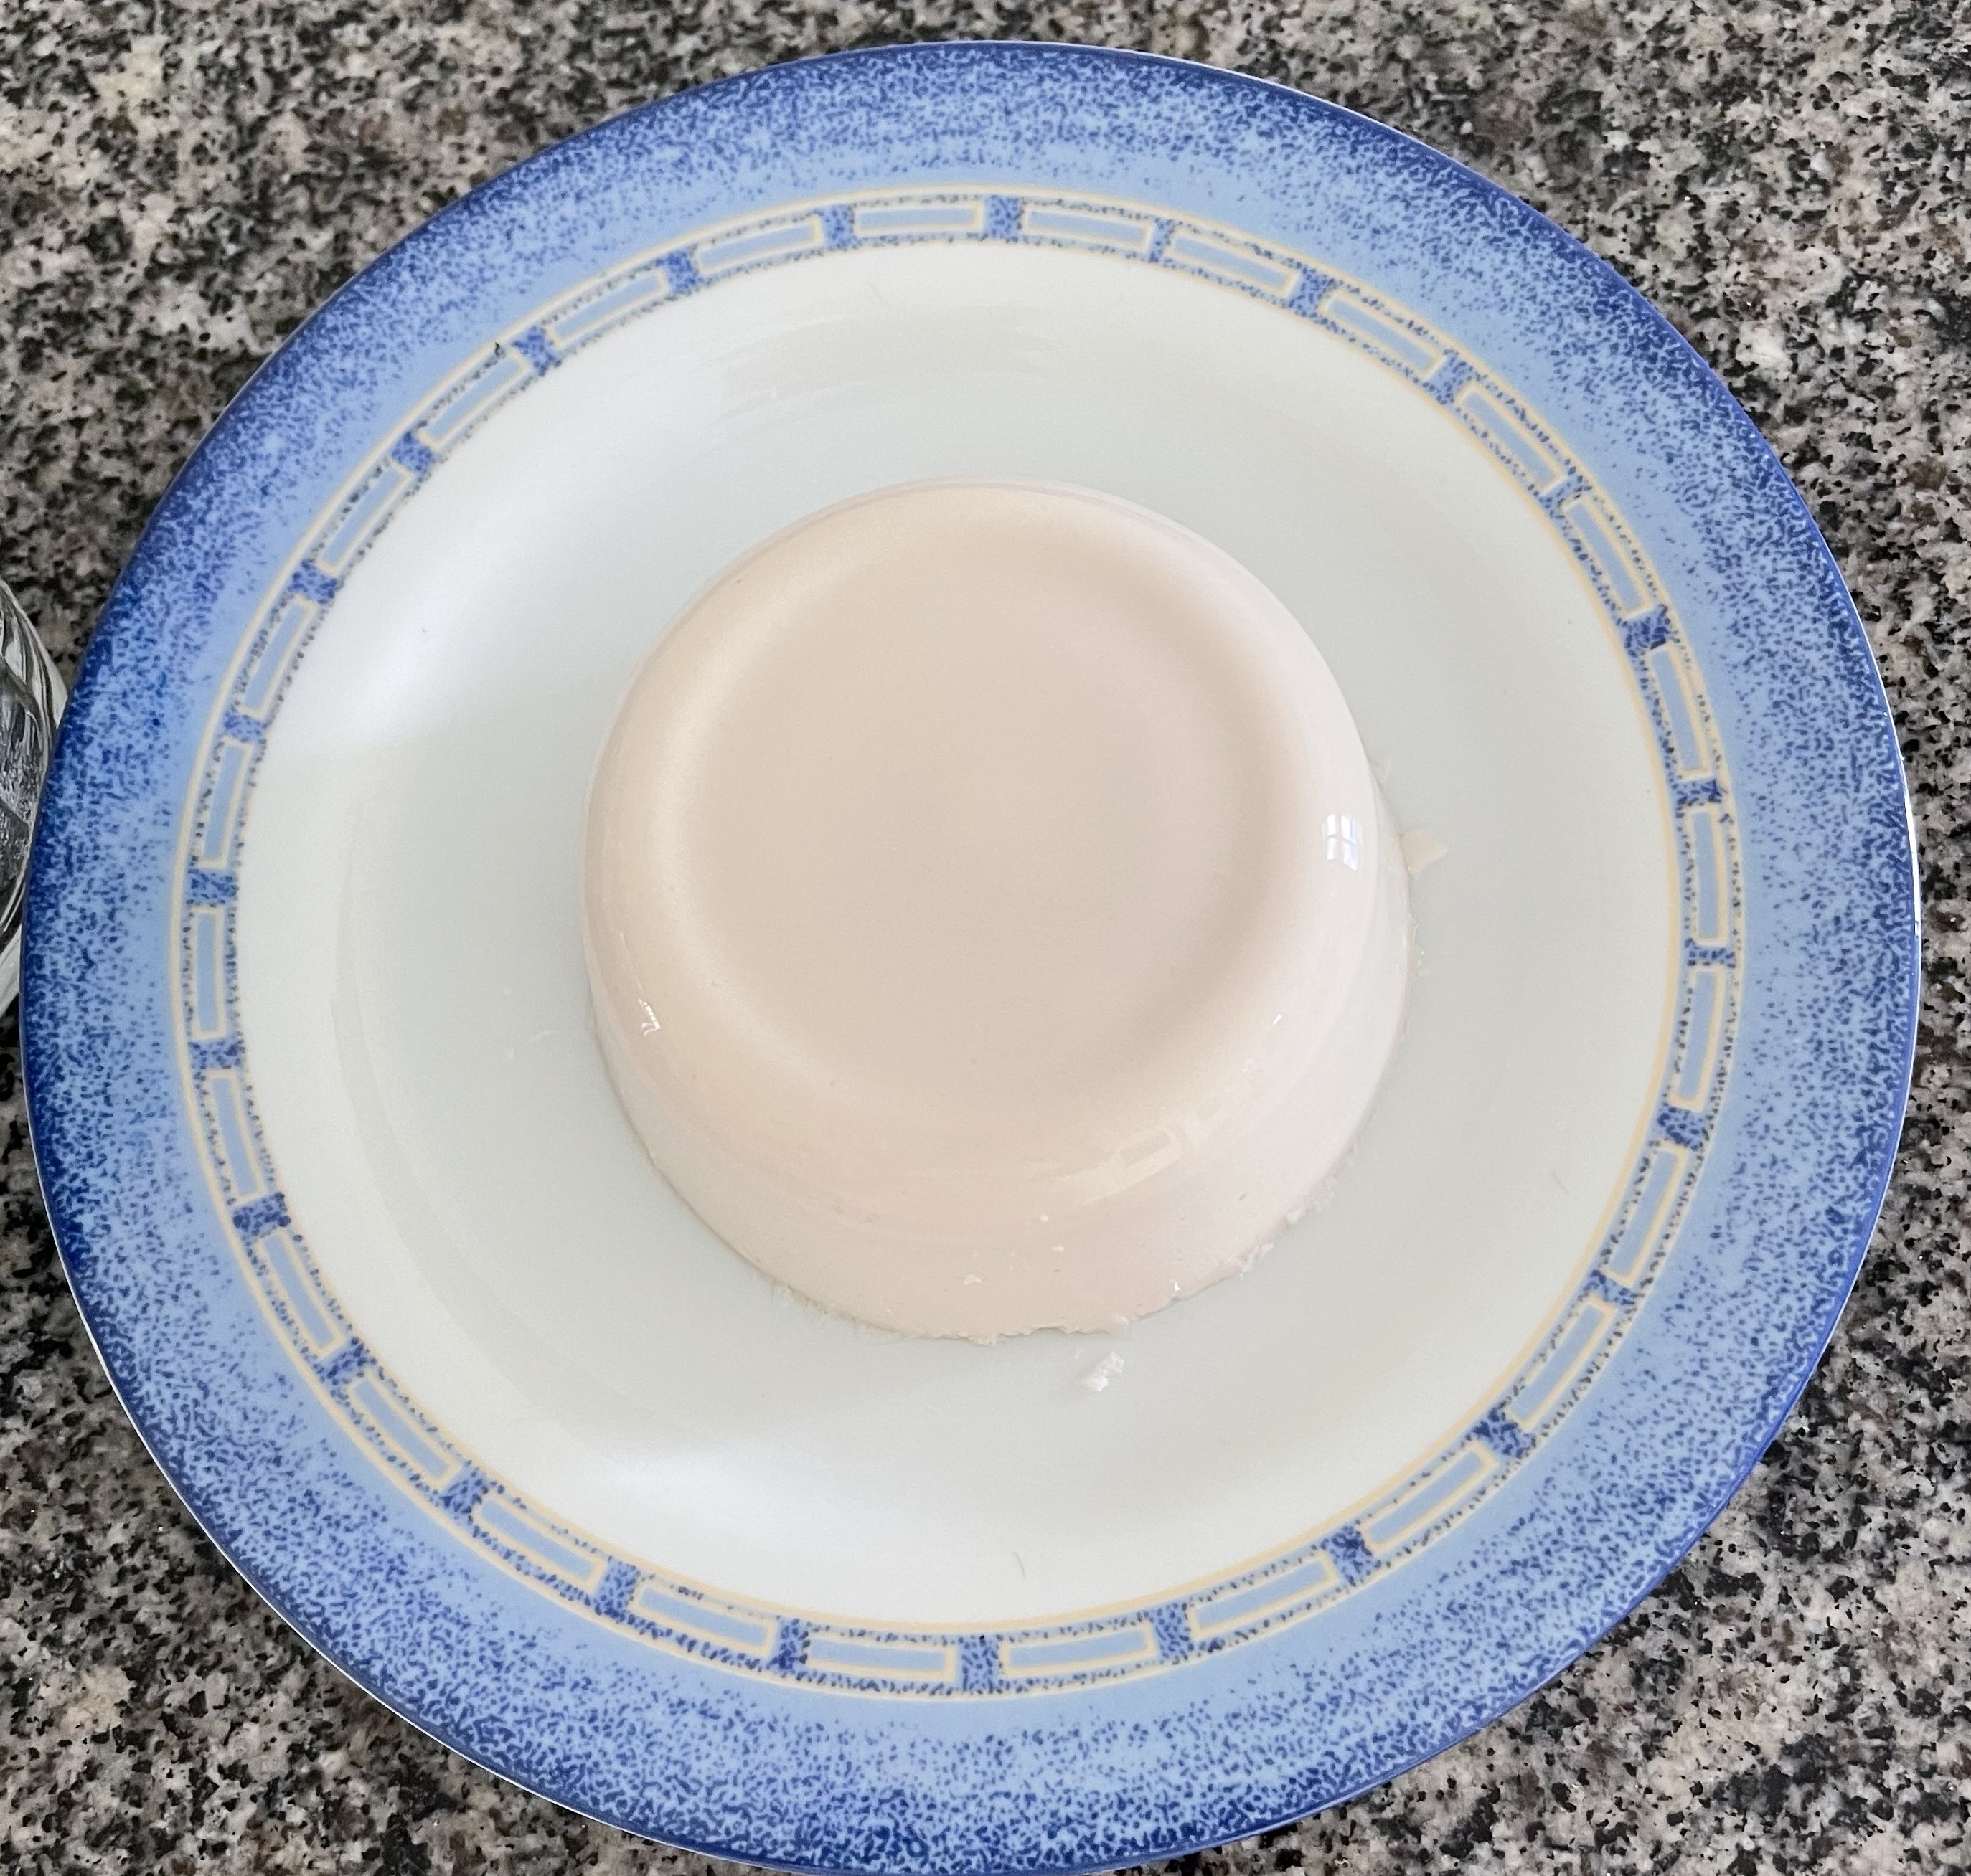  b
Figure 3: Hamburger analogue with cashew fiber, lentil and Spirulina (a) and cheese analogue process based on babassu coconut kernels (b). Photos: (a) Gean Rocha-Trainee and (b) Selene Benevides.
Table 1: Physical-chemical results of hamburger analogues with cashew fiber, lentils and Spirulina and babassu cheese.
Analogues | Moisture  B.U. (%) | Proteins  B.U. (%) | Lipids  B.U. (%) | Ashes  B.U. (%) | Total Fibers  B.U. (%) | Carbohydrates  (%)
Hamburger | 67,95±0,12 | 5,66±0,14 | 1,78±0,09 | 1,66±0,02 | 10,25±0,11 | 24,30±0,05
Cheese | 67,44±0,50 | 4,17±0,07 | 23,46±0,63 | 1,51±0,05 | 1,15±0,14 | 3,34±0,05

The hamburger analogue with cashew fiber, lentil and Spirulina presented good levels of protein and ash index, agreeing with Kumar et al. (2022), that suggested that an evaluation of the techno functional properties and bio efficacy of proteins such as Spirulina and benchmarking with existing plants proteins based on soy, pea, chickpea be carried out for greater acceptance. Carvajal (2009) obtained 54.83% of protein in the microalgae Spirulina maxima, demonstrating that, indeed, it can be considered a highly protein food source.
The protein index of the hamburger analogue with cashew fiber, lentil and Spirulina was similar the products developed by Lima et al. (2013), that incorporated the legume cowpea in a hamburger based on cashew fiber, obtained a protein content of 4.86%. In another study, Lima et al. (2016) observed protein value results of 4.8% for hamburger with pressed fiber and 5.7% for hamburger with pressed and macerated fiber.
The results of this study corroborate with the research by Maciel et al. (2022) where they state that the uses of freeze-dried cashew fiber as a base in analogues foods, can contribute to plant-based products market, exploring the possibilities of completely plant-based preparations.

The analogue milk of babassu coconut has a low protein content, but in the cheese, analogue was increased with the incorporation of soy extract and cassava starch, resulting in a protein content similar (approximately 5.6%) to that of a type of cheese traditionally consumed in Brazilian diets, called " Minas Frescal ".
The average values obtained for acidity and pH were, respectively, 0.22% and 5.50. The fermenting offers an acid taste, modifying the pH of the babassu coconut that has an original sweet taste (6.80 pH
making the cheese analogue similar to traditional cheeses. The fermenting transforms the characteristic sweet flavor of the babassu coconut milk reducing the pH, resulting in a cheese analogue with the flavor of traditional dairy products.
The cheese analogue presented 23.46% lipids, but Reipert et al. (2011) evaluated babassu oil and it contains a high level of lauric acid, the most abundant constituent (40–55%), and a higher content of unsaturated fatty acids (10-26%) than coconut oil (6-12%), an important texture agent in the food industry.
The texture showed mean values of hardness (153.00 g), adhesiveness (-52.90 g s), gumminess (25.2) and chewiness (10.60), characterizing the babassu cheese analogue as a semi-solid.

The cashew fiber hamburger analogues with legumes and Spirulina and babassu cheese reached a score of 7.0 in the assessment of overall acceptance, aroma and flavor, on a hedonic scale of 1 to 9. Lima (2008) developed burgers using cashew apple fiber and the overall impression attribute reported (5.9) was less compared in this research. Gomes et al. (2010) obtained a score of 6.18 for “Minas Frescal” cheese analogues with the addition of soy extract.
The purchase intention for hamburger analogue had an average value of 3.7 ranging between “maybe I would buy, maybe not buy” and “probably would buy”, on a scale of 1 to 5. The cheese analogue had an average value of 4.0 (“probably would buy”), showing market potential to meet the demand of consumers who look for foods with functional appeal and tasty.
  - Conclusions
Cashew fiber is a vegetable co-product of the juice processing industry that presents itself as an attractive alternative input, when incorporated together with alternative protein sources, such as lentils and Spirulina, in formulations of products like hamburgers.
Babassu coconut has potential as a raw material to produce cheese analogues, diversifying the portfolio of products derived from babassu, in addition to meeting the consumer market demand for plant-based products.
Acknowledgments
To the Brazilian Agricultural Research Company (Embrapa Cocais, Agroindústria Tropical and Hortaliças) for technical and financial support, to the Good Food Institute (GFI) by financial support of part of the research with hamburger analogue and Prof. Kelma Cavalcante, DSc., from the Department of Fishing Engineering at the Federal University of Ceará (UFC).

References
AOAC (Association of Official Analytical Chemists), Official Methods of Analysis off AOAC International, 2016, 20 ed., Editor: Dr. George W. Latimer, Jr. Rockville, MD, USA.
AOCS, American Oil Chemists’ Society, 2005, Official Method Am 5-04, Rapid determination of oil/fat utilizing high temperature solvent extraction, Urbana: Official Methods and Recommended Practices of the American Oil Chemists ́ Society.
Carneiro, B.L.A., Arévalo-Pinedo, A., Scartazzini, L., Giraldo-Zuniga, A.D., Pinedo, R.A., 2014, Study of the stability of the hydrosoluble extract "milk" of babassu (Orbygnia speciosa) pasteurized and stored under refrigeration, Rev. Bras. Frutic., Jaboticabal - SP, v. 36, n. 1, p.232-236, Março.
Carvajal, Juan Carlos Letelier, 2009, Microalgae; Proteins; Functional properties; Chemical modifications, 138
F, Thesis (PhD in Food Chemistry and Biochemistry) - Federal University of Paraíba, João Pessoa,
2009, (in Portuguese).
De Oliveira, N.A., Mazzali, M.R., Fukumasu, H., Goncalves, C.B., De Oliveira, A.L., 2019, Composition and physical properties of babassu seed (Orbignya phalerata) oil obtained by supercritical CO₂ extraction, J. of Supercritical Fluids, 150, 21-29.
Falkeisen, A., Gorman, M., Knowles, S., Barker, S., Moss, R., McSweeney, M.B., 2022, Consumer perception and emotional responses to plant-based cheeses, Food Research International, 158, 111513.
Figueiredo, R.W., Lajolo, F.M., Alves, R.E., Filgueiras, H.A.C., 2002. Physical-chemical changes in early dwarf
cashew pseudofruits during developments and maturation, Food Chem. 77, 343–347.
Galvão, A.M.P.G., 2006, Use of cashew fiber (Anacardium occidentale l.) in the formulation of a hamburger-like product, Dissertation (Master in Food Technology) – Center for Agricultural Sciences, Federal University of Ceará, Fortaleza, (in Portuguese).
Gomes, J.P., Prudencio, S.H., Da Silva, R.S. dos S.F., 2010, Minas frescal cheese with soy product: physical,
chemistry and sensorial characteristics, Food Science and Technology, vol. 30, no. 1, May, pp. 77-85.
Kumar, R., Hegde, A.S., Sharma, K., Parmar, P., Srivatsan, V., 2022, Microalgae as a sustainable source of edible proteins and bioactive peptides – Current trends and future prospects, Food Research International 157, 111338.
Lima, J.R., 2008, Physical-chemical and sensorial characterization of vegetable hamburger made with cashew nuts. Science and Agrotechnology, v. 32, n.1, jan./fev., p. 191 – 195, (in Portuguese).
Lima, J.R., Modesto, A.L.G., Firmino, D.S., Pinto, G.A.S., Lima, L.V. de; Oliveira, L.M.V. de, Wurlitzer, N.J., Paula Pessoa, P. F. A., 2013a, Vegetable hamburger with cashew fiber and textured soy protein: obtaining and evaluating the economic viability of the production, Fortress: Embrapa Tropical Agroindustry, 11 p., (Embrapa Tropical Agroindustry. Technical Notice, 208), (in Portuguese).
Lima, J.R., Garruti, D. dos S., Firmino, D.S., Araujo, I.M. Da S., Moraes, I.V.M. de., 2013b, Elaboration of vegetable hamburger with cashew fiber and cowpea, Fortaleza: Embrapa Tropical Agroindustry, 6 p. (Embrapa Tropical Agroindustry, Technical Notice, 203), (in Portuguese).
Lima, J.R., Garruti, D.S., Pinto, G.A.S., Magalhães, H.C.R., Machado, T.F., 2016, Vegetable burgers of cashew fiber and textured soy protein, Brazilian Magazine of Fruticulture, v. 39, n.3, p. 1-7, (in Portuguese).
Lima, J.R., Garruti, D.S., Machado, T.F., Araújo, Í.M.S. 2018, Cashew and cowpea fiber vegetable burgers: formulation, characterization and stability during frozen storage, Agronomic Science Magazine, Fortaleza, CE, v. 49, n. 4, p. 708-714, out./dez.
Maciel, J.B. Use of dehydrated cashew peduncle fiber in plant-based product formulations. 2022. 93 f. Dissertation (Master in Natural Sciences) - State University of Ceará, Science and Technology Center, Fortaleza, CE.
Meilgaard, M., Civille, G.V., Carr, B.T., 1987, Sensory evaluation techniques. London: CRC Press.
Müller, M., Canfora, E.E, Blaak, E.E., 2018, Gastrointestinal Transit Time, Glucose Homeostasis and Metabolic Health: Modulation by Dietary Fibers. Nutrients, Feb 28, 10(3):275.
Pinho, L.X., Afonso, M.R.A., Carioca, J.O.B., Costa, J.M.C., Ramos, A.M., 2011, The use of cashew apple residue as source of fiber in low fat hamburgers, Food Science and Technology, Campinas, v. 31, n.4, p. 941-945, out.-dez.
Reipert, E.C.D’A., Rodrigues, C.E.C., Meirelles, A.J.A., 2011, Phase equilibria study of systems composed of refined babassu oil, lauric acid, ethanol, and water at 303.2 K, J. Chem. Thermodyn., 43, pp. 1784-1790.
Sucupira, N.R., Sabino, L.B. de S., Gondim Neto, L., Gouveia, S.T., De Figueiredo, R.W., Maia, G.A., De Sousa, P.H.M., 2020, Evaluation of cooking methods on the bioactive compounds of cashew apple fibre and its application in plant-based foods, Heliyon 6, 1-9.

